DYNAMIC RAD
ORIGINAL RAD | TRIAL DYNAMIC RAD | TRIGGERING ZONE  in CACD | TRIAL RAD Increment File Placeholder | Lateral limits | Upper/lower limits | Remarks
1 | 2 | 3 | 4 | 5 | 6 | 7
LF
LF2107 | LFTZ2107X | LFTZ2107 | Annex 2B – Local and Cross-border Capacity and Structural Rules | 480830N - 0011545E  480830N - 0013045E  475830N - 0013045E  475830N - 0011545E | FL005  GND | 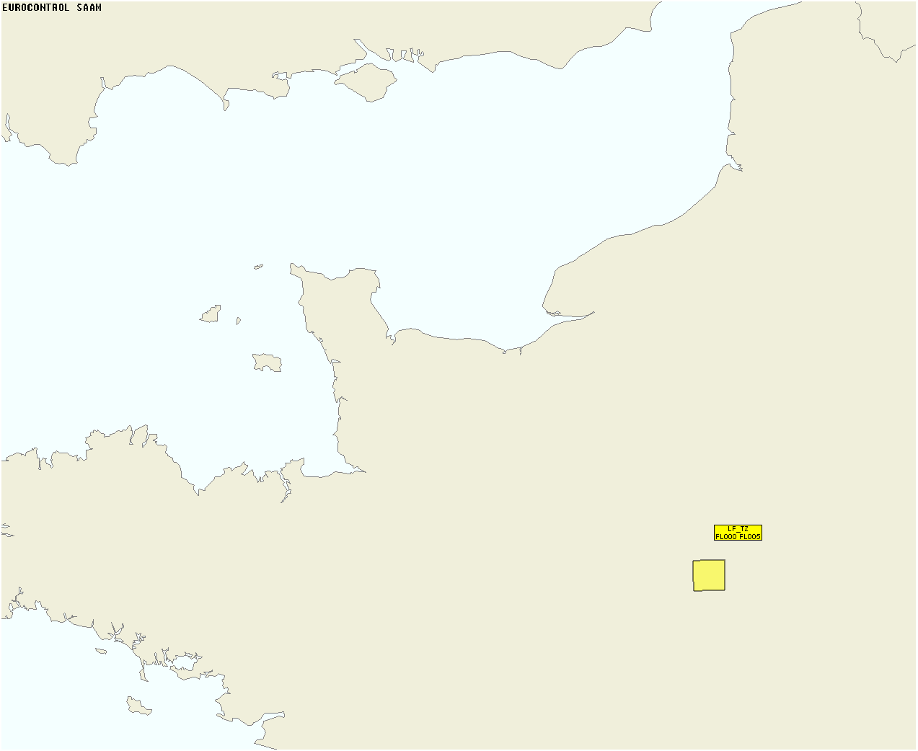 | H24 – Daily activation notified via EAUP/EUUP
LF2433 | LFTZ2433X | LFTZ2433 | Annex 2B – Local and Cross-border Capacity and Structural Rules | 480830N - 0011545E  480830N - 0013045E  475830N - 0013045E  475830N - 0011545E | FL005  GND |  | H24 – Daily activation notified via EAUP/EUUP
LF4411 | LFTZ4411X | LFTZ4411 | Annex 2A – Flight Level Capping Rules | 480830N - 0011545E  480830N - 0013045E  475830N - 0013045E  475830N - 0011545E | FL005  GND |  | H24 – Daily activation notified via EAUP/EUUP
LF4281 | LFTZ4281X | LFTZ4281 | Annex 2A – Flight Level Capping Rules | 480830N - 0011545E  480830N - 0013045E  475830N - 0013045E  475830N - 0011545E | FL005  GND |  | H24 – Daily activation notified via EAUP/EUUP
LF4436 | LFTZ4436X | LFTZ4436 | Annex 2A – Flight Level Capping Rules | 480830N - 0011545E  480830N - 0013045E  475830N - 0013045E  475830N - 0011545E | FL005  GND |  | H24 – Daily activation notified via EAUP/EUUP
LF4438 | LFTZ4438X | LFTZ4438 | Annex 2A – Flight Level Capping Rules | 480830N - 0011545E  480830N - 0013045E  475830N - 0013045E  475830N - 0011545E | FL005  GND |  | H24 – Daily activation notified via EAUP/EUUP
LF4439 | LFTZ4439X | LFTZ4439 | Annex 2A – Flight Level Capping Rules | 480830N - 0011545E  480830N - 0013045E  475830N - 0013045E  475830N - 0011545E | FL005  GND |  | H24 – Daily activation notified via EAUP/EUUP
LF4440 | LFTZ4440X | LFTZ4440 | Annex 2A – Flight Level Capping Rules | 480830N - 0011545E  480830N - 0013045E  475830N - 0013045E  475830N - 0011545E | FL005  GND |  | H24 – Daily activation notified via EAUP/EUUP
LF4441 | LFTZ4441X | LFTZ4441 | Annex 2A – Flight Level Capping Rules | 480830N - 0011545E  480830N - 0013045E  475830N - 0013045E  475830N - 0011545E | FL005  GND |  | H24 – Daily activation notified via EAUP/EUUP
LF4442 | LFTZ4442X | LFTZ4442 | Annex 2A – Flight Level Capping Rules | 480830N - 0011545E  480830N - 0013045E  475830N - 0013045E  475830N - 0011545E | FL005  GND |  | H24 – Daily activation notified via EAUP/EUUP
LF4443 | LFTZ4443X | LFTZ4443 | Annex 2A – Flight Level Capping Rules | 480830N - 0011545E  480830N - 0013045E  475830N - 0013045E  475830N - 0011545E | FL005  GND |  | H24 – Daily activation notified via EAUP/EUUP
LF2810 | LFTZ2810X | LFTZ2810 | Annex 2B – Local and Cross-border Capacity and Structural Rules | 480830N - 0011545E  480830N - 0013045E  475830N - 0013045E  475830N - 0011545E | FL005  GND |  | H24 – Daily activation notified via EAUP/EUUP
LF3006 | LFTZ3006X | LFTZ3006 | Annex 2B – Local and Cross-border Capacity and Structural Rules | 480830N - 0011545E  480830N - 0013045E  475830N - 0013045E  475830N - 0011545E | FL005  GND |  | H24 – Daily activation notified via EAUP/EUUP
NM4012 | NM4012A | LFTZ4012 | Annex 2A – Flight Level Capping Rules | 480830N - 0011545E  480830N - 0013045E  475830N - 0013045E  475830N - 0011545E | FL005  GND |  | H24 – Daily activation notified via EAUP/EUUP
NM4013 | NM4013A | LFTZ4013 | Annex 2A – Flight Level Capping Rules | 480830N - 0011545E  480830N - 0013045E  475830N - 0013045E  475830N - 0011545E | FL005  GND |  | H24 – Daily activation notified via EAUP/EUUP
NM4014 | NM4014A | LFTZ4014 | Annex 2A – Flight Level Capping Rules | 480830N - 0011545E  480830N - 0013045E  475830N - 0013045E  475830N - 0011545E | FL005  GND |  | H24 – Daily activation notified via EAUP/EUUP
NM2101 | NM2101A | LFTZ2101 | Annex 2B – Local and Cross-border Capacity and Structural Rules | 480830N - 0011545E  480830N - 0013045E  475830N - 0013045E  475830N - 0011545E | FL005  GND |  | H24 – Daily activation notified via EAUP/EUUP

EF
EF2046 | EFTZ2046X | EFTZ2046 | Annex 2B: Local and Cross-border Capacity and Structural Rules | 601400N - 0242800E  601400N - 0243000E  601300N - 0243000E  601300N - 0242800E | FL005  GND | 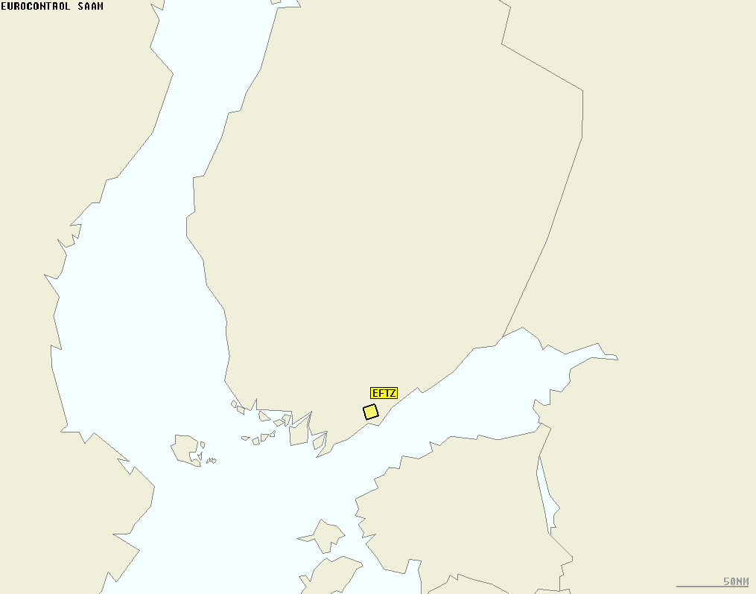 | H24 – Daily activation notified via EAUP/EUUP
EF2047 | EFTZ2047X | EFTZ2047 | Annex 2B: Local and Cross-border Capacity and Structural Rules | 601400N - 0242800E  601400N - 0243000E  601300N - 0243000E  601300N - 0242800E | FL005  GND |  | H24 – Daily activation notified via EAUP/EUUP
EF2048 | EFTZ2048X | EFTZ2048 | Annex 2B: Local and Cross-border Capacity and Structural Rules | 601400N - 0242800E  601400N - 0243000E  601300N - 0243000E  601300N - 0242800E | FL005  GND |  | H24 – Daily activation notified via EAUP/EUUP
EF2049 | EFTZ2049X | EFTZ2049 | Annex 2B: Local and Cross-border Capacity and Structural Rules | 601400N - 0242800E  601400N - 0243000E  601300N - 0243000E  601300N - 0242800E | FL005  GND |  | H24 – Daily activation notified via EAUP/EUUP
EF2050 | EFTZ2050X | EFTZ2050 | Annex 2B: Local and Cross-border Capacity and Structural Rules | 601400N - 0242800E  601400N - 0243000E  601300N - 0243000E  601300N - 0242800E | FL005  GND |  | H24 – Daily activation notified via EAUP/EUUP
EF2051 | EFTZ2051X | EFTZ2051 | Annex 2B: Local and Cross-border Capacity and Structural Rules | 601400N - 0242800E  601400N - 0243000E  601300N - 0243000E  601300N - 0242800E | FL005  GND |  | H24 – Daily activation notified via EAUP/EUUP
EF2052 | EFTZ2052X | EFTZ2052 | Annex 2B: Local and Cross-border Capacity and Structural Rules | 601400N - 0242800E  601400N - 0243000E  601300N - 0243000E  601300N - 0242800E | FL005  GND |  | H24 – Daily activation notified via EAUP/EUUP

ES
ES2009 | ESTZ2009X | ESTZ2009 | Annex 2B: Local and Cross-border Capacity and Structural Rules | 685400N - 0203700E  685400N - 0204000E  685300N - 0204000E  685300N - 0203700E | FL005  GND | 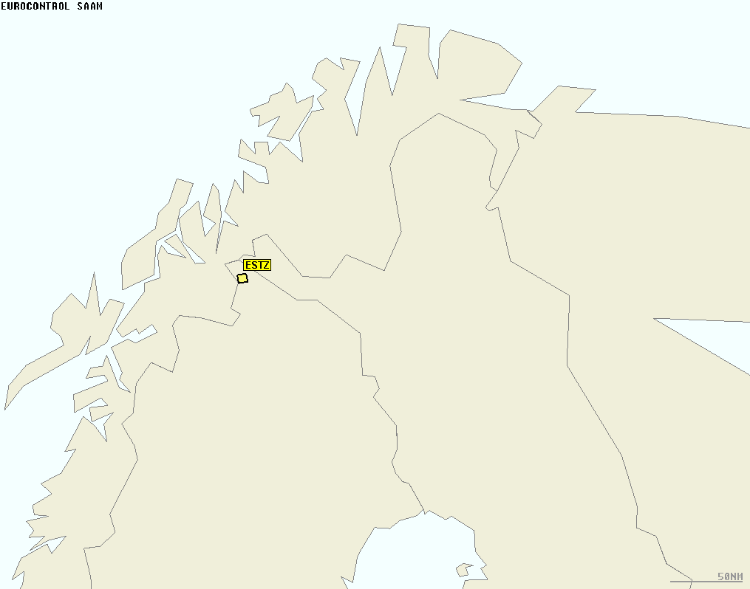 | H24 – Daily activation notified via EAUP/EUUP
ES2010 | ESTZ2010X | ESTZ2010 | Annex 2B: Local and Cross-border Capacity and Structural Rules | 685400N - 0203700E  685400N - 0204000E  685300N - 0204000E  685300N - 0203700E | FL005  GND |  | H24 – Daily activation notified via EAUP/EUUP
ES2011 | ESTZ2011X | ESTZ2011 | Annex 2B: Local and Cross-border Capacity and Structural Rules | 685400N - 0203700E  685400N - 0204000E  685300N - 0204000E  685300N - 0203700E | FL005  GND |  | H24 – Daily activation notified via EAUP/EUUP
ES2012 | ESTZ2012X | ESTZ2012 | Annex 2B: Local and Cross-border Capacity and Structural Rules | 685400N - 0203700E  685400N - 0204000E  685300N - 0204000E  685300N - 0203700E | FL005  GND |  | H24 – Daily activation notified via EAUP/EUUP
ES2013 | ESTZ2013X | ESTZ2013 | Annex 2B: Local and Cross-border Capacity and Structural Rules | 685400N - 0203700E  685400N - 0204000E  685300N - 0204000E  685300N - 0203700E | FL005  GND |  | H24 – Daily activation notified via EAUP/EUUP
ES2014 | ESTZ2014X | ESTZ2014 | Annex 2B: Local and Cross-border Capacity and Structural Rules | 685400N - 0203700E  685400N - 0204000E  685300N - 0204000E  685300N - 0203700E | FL005  GND |  | H24 – Daily activation notified via EAUP/EUUP

LE
LE2090 | LETZ2090B | LETZ2090 | Annex 2B – Local and Cross-border Capacity and Structural Rules | 400000N - 0000000E  400000N - 0000100E  395900N - 0000100E  395900N - 0000000E | FL005  GND | 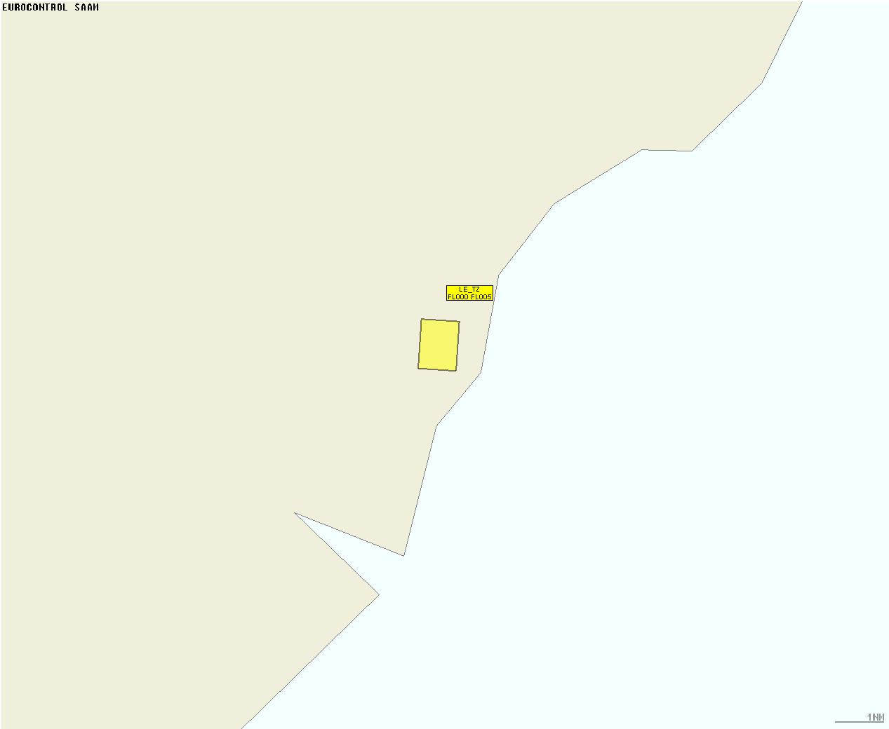 | H24 – Daily activation notified via EAUP/EUUP  MANAGING LE3192 AND LE2090 RESTRICTIONS (DCT ANZAN-TOPTU ADDITIONAL AVAILABILITY BETWEEN 05:00..00:00 (04:00..23:00))
LE2122 | LETZ2122C | LETZ2122 | Annex 2B – Local and Cross-border Capacity and Structural Rules | 400000N - 0000000E  400000N - 0000100E  395900N - 0000100E  395900N - 0000000E | FL005  GND |  | H24 – Daily activation notified via EAUP/EUUP  MANAGING LE2271 AND LE2122 RESTRICTIONS (DCT ASTRO-DELOG ADDITIONAL AVAILABILITY BETWEEN 05:00..00:00 (04:00..23:00))
LE2149 | LETZ2149B | LETZ2149 | Annex 2B – Local and Cross-border Capacity and Structural Rules | 400000N - 0000000E  400000N - 0000100E  395900N - 0000100E  395900N - 0000000E | FL005  GND |  | H24 – Daily activation notified via EAUP/EUUP  MANAGING LE2271 AND LE2149 RESTRICTIONS (DCT BARDI-DELOG ADDITIONAL AVAILABILITY BETWEEN 05:00..00:00 (04:00..23:00))
LE2188 | LETZ2188BX | LETZ2188X | Annex 2B – Local and Cross-border Capacity and Structural Rules | 400000N - 0000000E  400000N - 0000100E  395900N - 0000100E  395900N - 0000000E | FL005  GND |  | H24 – Daily activation notified via EAUP/EUUP  MANAGING LE2907 AND LE2188 RESTRICTIONS (DCT BERUM-NUNKA ADDITIONAL AVAILABILITY BETWEEN 05:00..00:00 (04:00..23:00))
LE2188 | LETZ2188BY | LETZ2188Y | Annex 2B – Local and Cross-border Capacity and Structural Rules | 400000N - 0000000E  400000N - 0000100E  395900N - 0000100E  395900N - 0000000E | FL005  GND |  | H24 – Daily activation notified via EAUP/EUUP  MANAGING LE2841 AND LE2188 RESTRICTIONS (DCT BERUM-MORAL ADDITIONAL AVAILABILITY BETWEEN 05:00..00:00 (04:00..23:00))
LE2268 | LETZ2268B | LETZ2268 | Annex 2B – Local and Cross-border Capacity and Structural Rules | 400000N - 0000000E  400000N - 0000100E  395900N - 0000100E  395900N - 0000000E | FL005  GND |  | H24 – Daily activation notified via EAUP/EUUP  MANAGING LE2701 AND LE2268 RESTRICTIONS (DCT CRISA-KORNO ADDITIONAL AVAILABILITY BETWEEN 05:00..00:00 (04:00..23:00))
LE2647 | LETZ2647B | LETZ2647X | Annex 2B – Local and Cross-border Capacity and Structural Rules | 400000N - 0000000E  400000N - 0000100E  395900N - 0000100E  395900N - 0000000E | FL005  GND |  | H24 – Daily activation notified via EAUP/EUUP  MANAGING LE3102 AND LE2647 RESTRICTIONS (DCT HAMRA-RUTIP ADDITIONAL AVAILABILITY BETWEEN 05:00..00:00 (04:00..23:00))
LE2647 | LETZ2647C | LETZ2647Y | Annex 2B – Local and Cross-border Capacity and Structural Rules | 400000N - 0000000E  400000N - 0000100E  395900N - 0000100E  395900N - 0000000E | FL005  GND |  | H24 – Daily activation notified via EAUP/EUUP  MANAGING LE2121 AND LE2647 RESTRICTIONS (DCT HAMRA-ASTRO ADDITIONAL AVAILABILITY BETWEEN 05:00..00:00 (04:00..23:00))
LE2842 | LETZ2842B | LETZ2842 | Annex 2B – Local and Cross-border Capacity and Structural Rules | 400000N - 0000000E  400000N - 0000100E  395900N - 0000100E  395900N - 0000000E | FL005  GND |  | H24 – Daily activation notified via EAUP/EUUP  MANAGING LE2181 AND LE2842 RESTRICTIONS (DCT MORAL-BELEN ADDITIONAL AVAILABILITY BETWEEN 05:00..00:00 (04:00..23:00))
LE2906 | LETZ2906B | LETZ2906 | Annex 2B – Local and Cross-border Capacity and Structural Rules | 400000N - 0000000E  400000N - 0000100E  395900N - 0000100E  395900N - 0000000E | FL005  GND |  | H24 – Daily activation notified via EAUP/EUUP  MANAGING LE2761 AND LE2906 RESTRICTIONS (DCT NUNKA-LUMAS ADDITIONAL AVAILABILITY BETWEEN 05:00..00:00 (04:00..23:00))
LE3021 | LETZ3021B | LETZ3021 | Annex 2B – Local and Cross-border Capacity and Structural Rules | 400000N - 0000000E  400000N - 0000100E  395900N - 0000100E  395900N - 0000000E | FL005  GND |  | H24 – Daily activation notified via EAUP/EUUP  MANAGING LE2761 AND LE3021 RESTRICTIONS (DCT PONEN-LUMAS ADDITIONAL AVAILABILITY BETWEEN 05:00..00:00 (04:00..23:00))
LE3034 | LETZ3034B | LETZ3034 | Annex 2B – Local and Cross-border Capacity and Structural Rules | 400000N - 0000000E  400000N - 0000100E  395900N - 0000100E  395900N - 0000000E | FL005  GND |  | H24 – Daily activation notified via EAUP/EUUP  MANAGING LE3106 AND LE3034 RESTRICTIONS (DCT PUMAL-SADAF ADDITIONAL AVAILABILITY BETWEEN 05:00..00:00 (04:00..23:00))
LE3107 | LETZ3107B | LETZ3107 | Annex 2B – Local and Cross-border Capacity and Structural Rules | 400000N - 0000000E  400000N - 0000100E  395900N - 0000100E  395900N - 0000000E | FL005  GND |  | H24 – Daily activation notified via EAUP/EUUP  MANAGING LE2761 AND LE3107 RESTRICTIONS (DCT SADAF-LUMAS ADDITIONAL AVAILABILITY BETWEEN 05:00..00:00 (04:00..23:00))

